|  |
| --- |
| **CSE535: Information Retrieval (Fall’18)**  **Project 3:** Evaluation of IR models |

**Vishal Shivaji Gawade**

Department of Computer Science

University at Buffalo

Buffalo, NY,14226

[*vgawade@buffalo.edu*](mailto:vgawade@buffalo.edu)

*vgawade(UBIT Name)*

**Abstract**

The goal of this project is to implement various IR models, evaluate the IR system and improve the search result based on understanding of the models, the implementation and the evaluation.

**1. Implementing IR models**

We have given three IR models to evaluate. First, we are going to use trec evaluation on default setting of these IR models. Together with our training queries, query results, ground truth judgements and the TREC_eval result, we gain an intuition on the performance of our IR system. We choose the measure **MAP** as main objective to improve. For our evaluation we are going to consider **top 20** results. We will be going to use below techniques to improve our models and evaluation score.

1. Tuning parameters of different models to see if it improves the MAP value.
2. Using SynonymGraphFilterFactory on fields
3. Using different tokenizer and analyzer on fields to check if it improves the results.
4. Trying query expansion by converting query into different languages, which might help to improve evaluation score.
5. Boosting the query based on different fields
6. Implementing different query parsers and check whether it helps to improve score.

**2. Models with default setting**

First, let’s create three cores for three different models. If we just use <similarity> tag in schema.xml file and mention similarity class name as BM25/VSM/DFR, all of them have their different model parameters set to some default value. We are going to compare the results of these default setting.

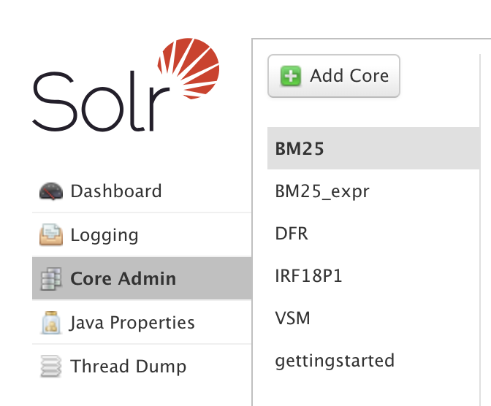

Figure 1: Cores in Solr

We have created modified query for each given query. For example, given below,

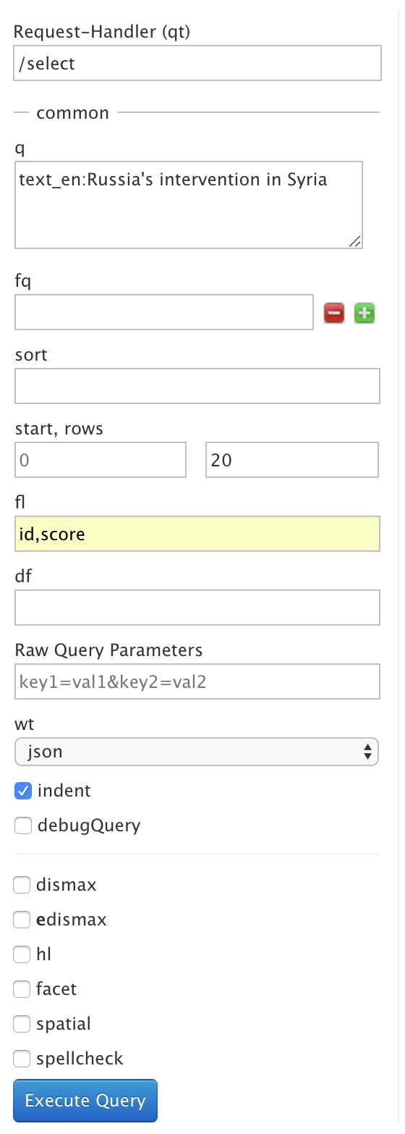

Figure 2: Querying in Solr

**2.1 Vector Space Model (VSM)**

Schema.xml-

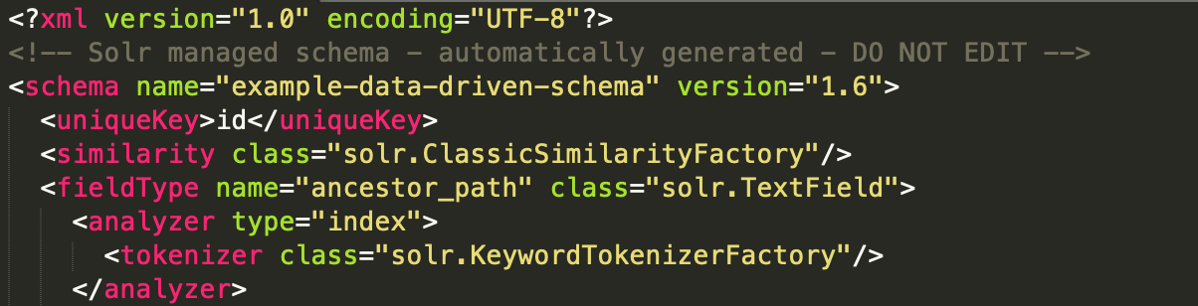

Figure 3: Schema.xml for default VSM

Let’s run all the queries on our model and execute json to trec python script to get top 20 results. Below is the screenshot of first query’s top 20 result.

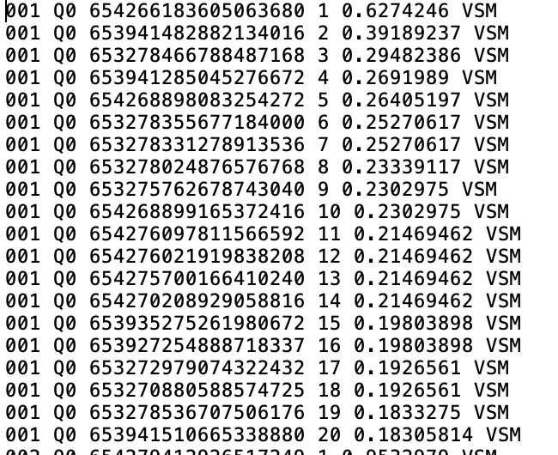

Figure 4: json to trec result for query 001 in default VSM

Now we will store all 15 queries top 20 results in txt file.

We are going to run trec_eval command to compare our results with trec’s qrel.txt

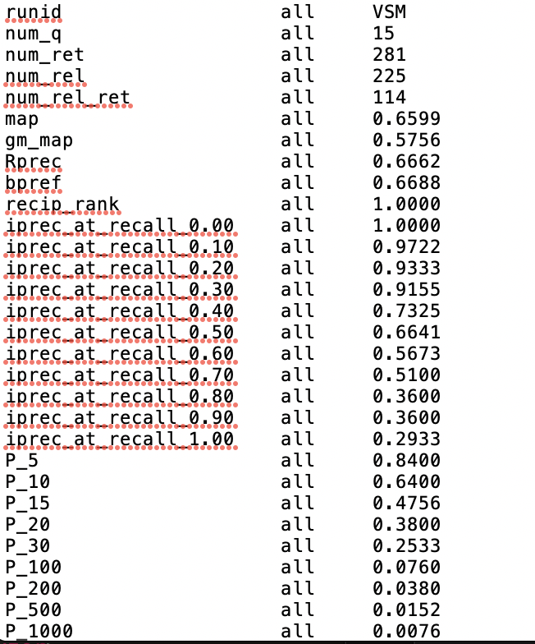

Figure 5: trec_eval for default VSM

**2.2 Divergence from Randomness Model (DFR)**

Schema.xml-

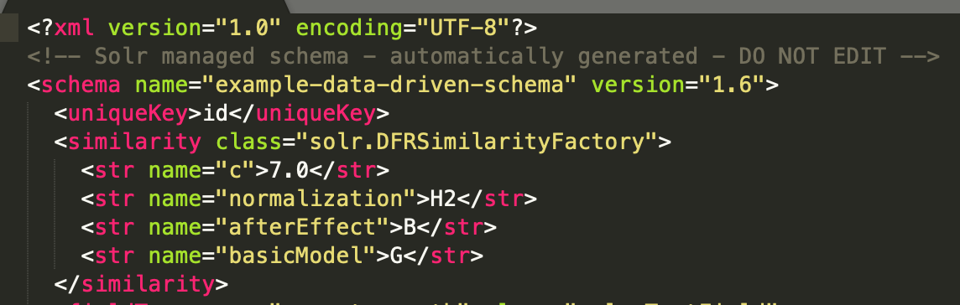

Figure 6: Schema.xml for default DFR

Let’s run all the queries on our model and execute json to trec python script to get top 20 results. Below is the screenshot of first query’s top 20 result.

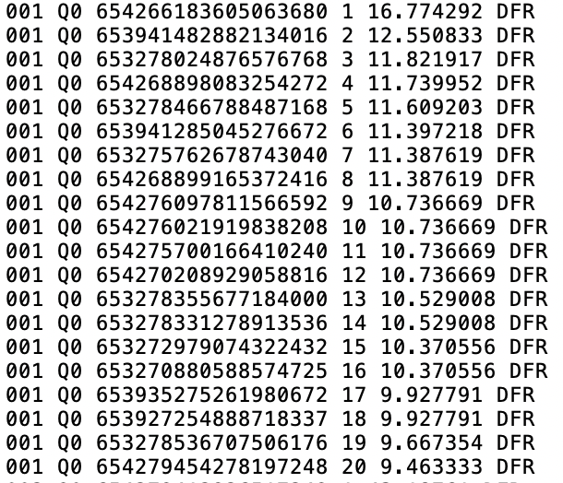

Figure 7: json to trec result for query 001 in default DFR

Now we will store all 15 queries top 20 results in txt file.

We are going to run trec_eval command to compare our results with trec’s qrel.txt

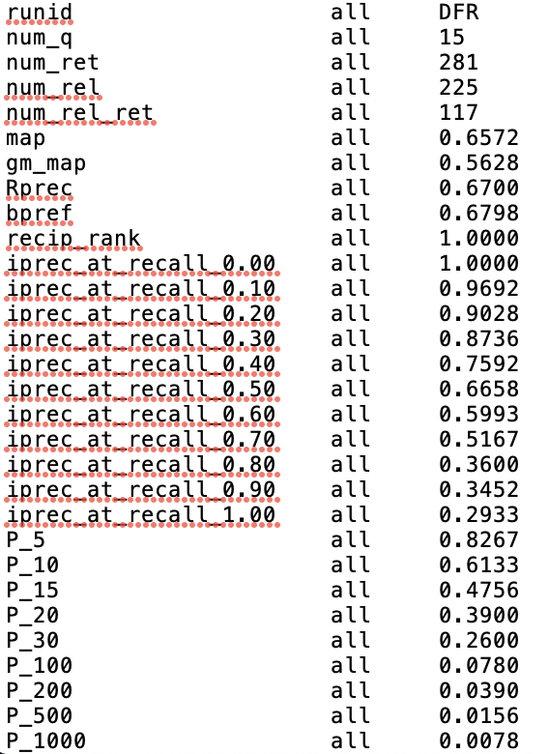

Figure 8: trec_eval for default DFR

**2.3 BM25**

Schema.xml-



Figure 9: Schema.xml for default BM25

Let’s run all the queries on our model and execute json to trec python script to get top 20 results. Below is the screenshot of first query’s top 20 result.

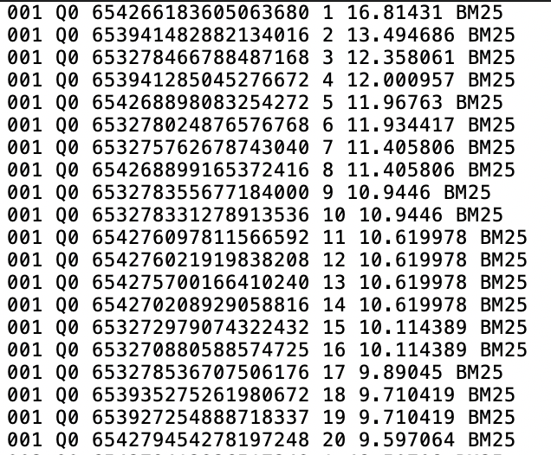

Figure 10: json to trec result for query 001 in default BM25

Now we will store all 15 queries top 20 results in txt file.

We are going to run trec_eval command to compare our results with trec’s qrel.txt

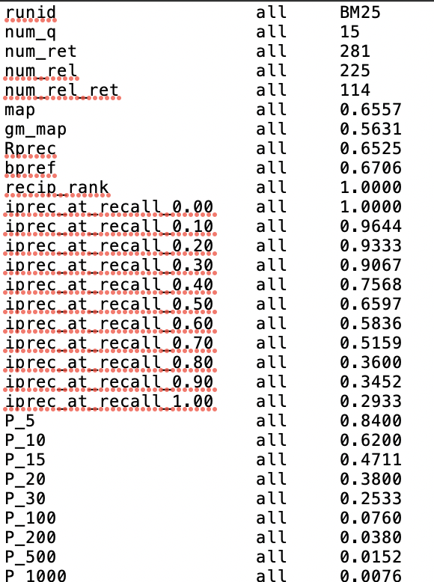

Figure 11: trec_eval for default BM25

**3. Model Improvements**

We tweaked the model as mentioned in the topic 1

* 1. **Model parameter tuning**

**A) BM25**

Let’s see map value by keeping k1=2 as a constant.

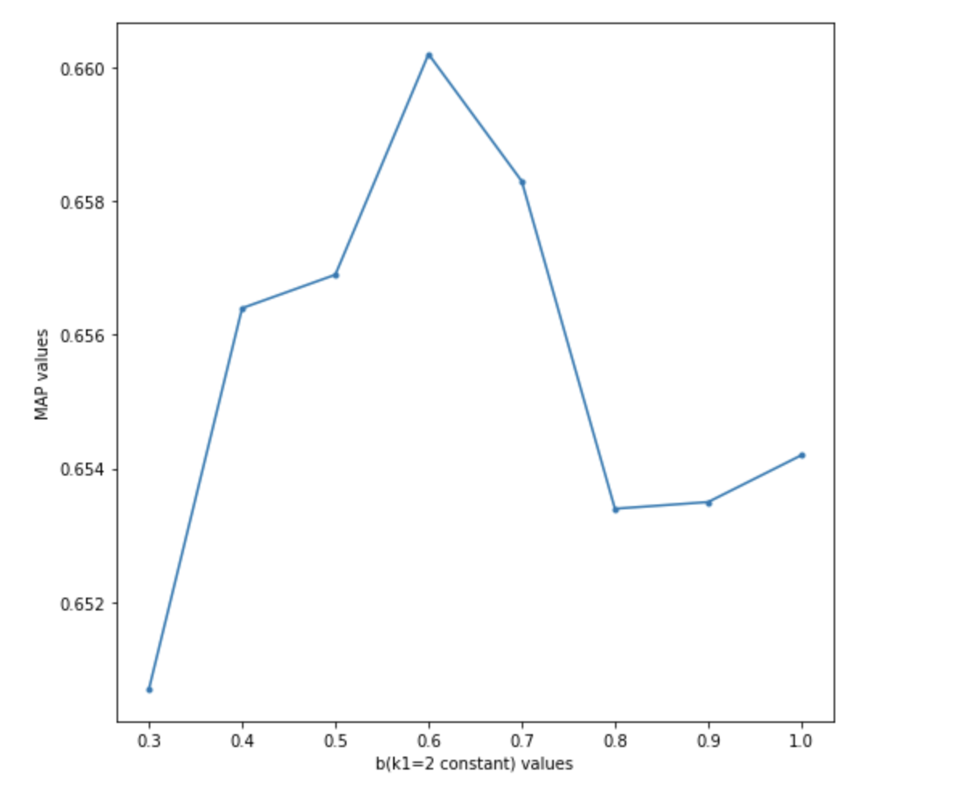

Figure 12: b vs MAP for BM25

As we can see if we keep increasing value of b from 0.3 to 1 we get max map value at b=0.6

From now onwards for other tweaking’s we are going to use b=0.6 for all BM25 improvement.

Now let’s keep b=0.6 constant and increase k1’s value.

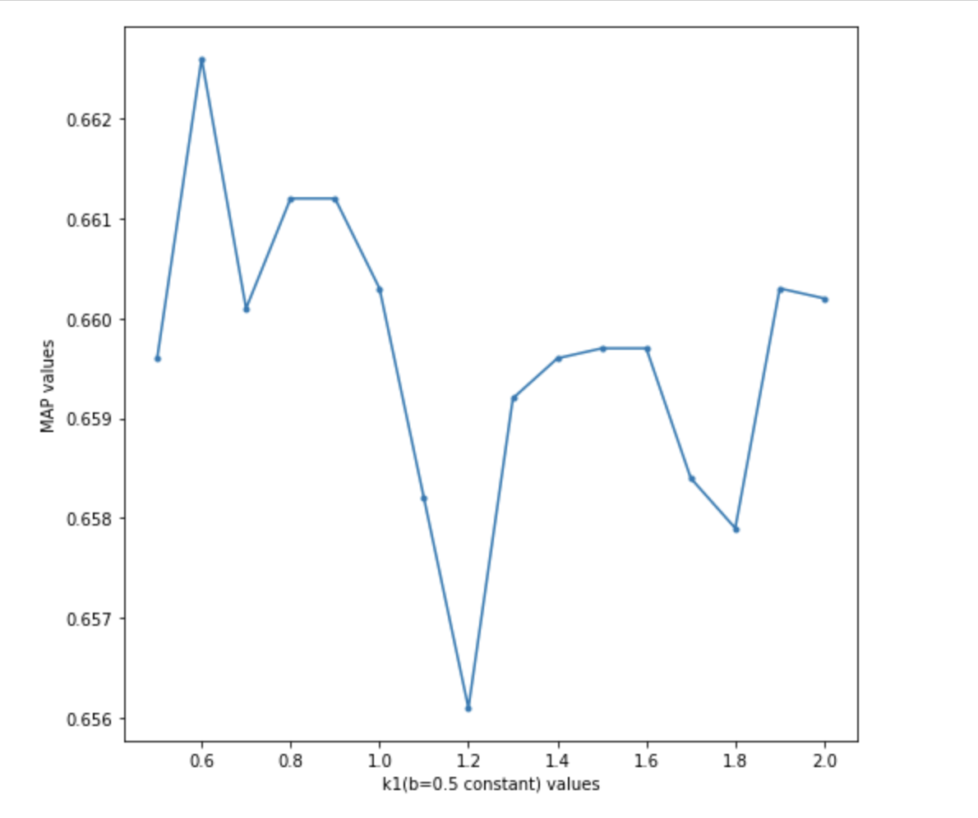

Figure 13: k1 vs Map for BM25

As we can see if we keep increasing value of k1 from 0.5 to 2 we get max map value at k1=0.6

From now onwards for other tweaking’s we are going to use k1=1.2 and b=0.6 for all BM25 improvements

**B) DFR**

There are main for parameters to tweak. Let’s keep c=7.0 (it’s default value) and change other fields and let see how map value gets affected.

Table 1: Parameter tuning results for DFR

|  |  |  |  |
| --- | --- | --- | --- |
| Basic Model | After Effect | Normalization | Map |
| G | B | H2 | 0.6572 |
| I(F) | B | H2 | 0.6561 |
| I(ne) | B | H2 | 0.6521 |
| I(n)` | L | H2 | 0.6553 |
| P | L | H2 | 0.6568 |
| G | B | Z | 0.6473 |
| G | B | H3 | 0.6538 |
| G | B | H1 | 0.6459 |

As we can see we are getting maximum value for default model of DFR.

Therefore, from now on we are going to use “BasicModelG” plus “Bernoulli” first normalization plus “H2” second normalization for DFR model. Changing C’s value to 1.0 gives best result with above combination.

**C) VSM**

Using SweetSpotSimilarityFactory**-**

SweetSpotSimilarityFactory similarity is subclass of ClassicSimilarityFactory. If we use SweetSpotSimilarityFactory instead of ClassicSimilarityFactory we don’t see any improvements in result.

Table 2: Parameter tuning results for VSM

|  |  |
| --- | --- |
| Similarity Factory name | MAP |
| ClassicSimilarityFactory | 0.6599 |
| SweetSpotSimilarityFactory | 0.6577 |

Therefore, from now onwards we are going to stick withClassicSimilarityFactory for model improvement.

**3.2 Using SynonymGraphFilterFactory on fields**

I added SynonymGraphFilterFactory to schema.xml file for text_en, text_ru and text_de.

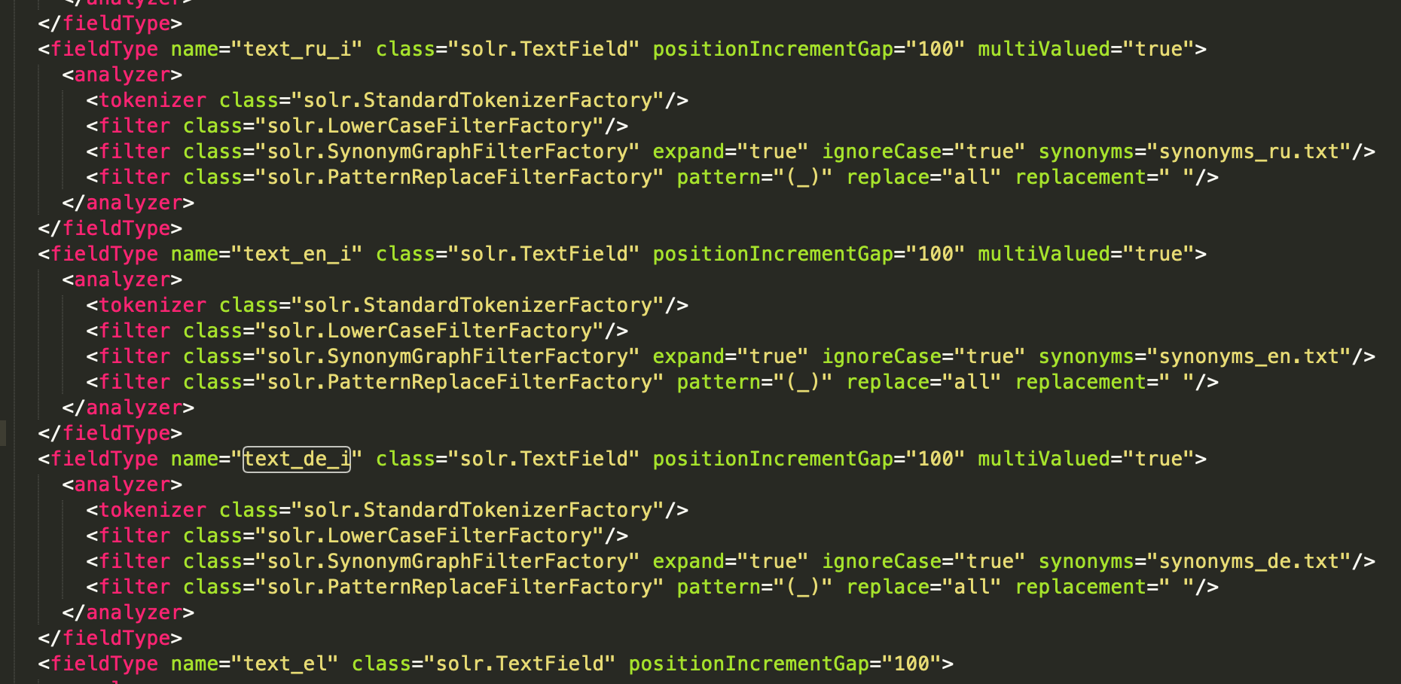

Figure 14: Schema.xml for SynonymGraphFilterFactory

Also created customized synonyms txt files for different languages. But it did not help in increasing the map value and relevancy. Also, this synonym mapping caused to get more false positives in our results. That’s why instead of it help in increasing our score value it decreased it. Therefore, I am going to use query expansion instead of SynonymGraphFilterFactory.

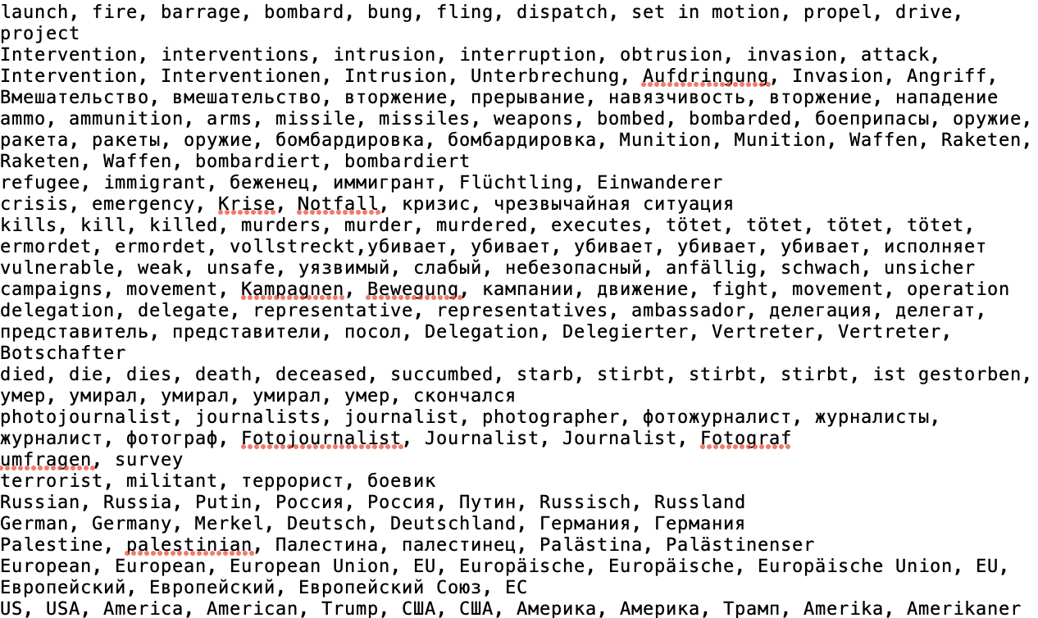

Figure 15: synonyms_en.txt snippet

I tried NGramTokenizerFactory tokenizer for Russian and German tweets but it did not perform better than our previous implementation. Also, I tried UAX29URLEmailTokenizerFactory for text_en, text_ru, text_de fields but it did not help.

**3.3 Adding tokenizer and analyzer and query expansion**

Let’s add type of fields text_en, text_ru and text_de as shown in below schema.xml snippet.

We are using standard field types text_en, text_ru and text_de present in schema.xml without any modification.

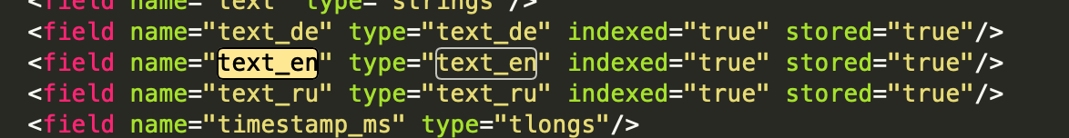

Figure 16: Schema.xml snippet

We expanded query by translating each query in German, English and Russian and then performing query operation. For example, let’s look at below expansion of query 001

Query- 001 Russia's intervention in Syria



Figure 17: Query expansion in Solr

Expanded query- <http://localhost:8983/solr/BM25/select?q=Russia%27s%5C%20intervention%5C%20in%5C%20Syria%20OR%20Intervention%5C%20Russlands%5C%20in%5C%20Syrien%20OR%20%D0%92%D1%81%D1%82%D1%83%D0%BF%D0%BB%D0%B5%D0%BD%D0%B8%D0%B5%5C%20%D0%A0%D0%BE%D1%81%D1%81%D0%B8%D0%B8%5C%20%D0%B2%5C%20%D0%A1%D0%B8%D1%80%D0%B8%D1%8E&fl=id%2Cscore&wt=json&indent=true&rows=20>

In above link just replace BM25 by VSM/DFR for those models

Now we will see how each model get affected by this change,

Table 3: Model comparison after query expansion

|  |  |  |  |  |  |
| --- | --- | --- | --- | --- | --- |
| Model | Total number of relevant docs | Number of relevant docs retrieved | | MAP | |
| Before this step | After this step | Before this step | After this step |
| BM25 | 225 | 114 | 115 | 0.6557 | 0.6661 |
| DFR | 225 | 117 | 119 | 0.6572 | 0.6636 |
| VSM | 225 | 114 | 117 | 0.6599 | 0.6711 |

As we can see in each model, number of retrieved relevant tweets are more than before applying tokenizer, analyzer and query expansion. Also map value also gets increased because of number of relevant tweets. This advanced query processing helped to increase map value because previously we are just searching tweet in their respective language. But now we expanded our scope to tweets which are present in other languages also. Tokenizer and analyzer helped to remove stop words and stemmed the query.

If we compare all the models from above table we see that VSM model took most of the advantage of this step because of its tf-idf evaluation.

**3.4 Boosting the query based on different fields**

Previous Expanded query 001 - <http://localhost:8983/solr/BM25/select?q=Russia%27s%5C%20intervention%5C%20in%5C%20Syria%20OR%20Intervention%5C%20Russlands%5C%20in%5C%20Syrien%20OR%20%D0%92%D1%81%D1%82%D1%83%D0%BF%D0%BB%D0%B5%D0%BD%D0%B8%D0%B5%5C%20%D0%A0%D0%BE%D1%81%D1%81%D0%B8%D0%B8%5C%20%D0%B2%5C%20%D0%A1%D0%B8%D1%80%D0%B8%D1%8E&fl=id%2Cscore&wt=json&indent=true&rows=20>

After adding term boost for 001 query-

[http://localhost:8983/solr/DFR/select?q=Russia^1.2%27s%5C%20intervention^0.7%5C%20in%5C%20Syria%20OR%20Intervention^0.7%5C%20Russlands^1.2%5C%20in%5C%20Syrien%20OR%20%D0%92%D1%81%D1%82%D1%83%D0%BF%D0%BB%D0%B5%D0%BD%D0%B8%D0%B5^0.7%5C%20%D0%A0%D0%BE%D1%81%D1%81%D0%B8%D0%B8^1.2%5C%20%D0%B2%5C%20%D0%A1%D0%B8%D1%80%D0%B8%D1%8E&fl=id%2Ctext_*%2Cscore&wt=json&indent=true&rows=20](http://localhost:8983/solr/DFR/select?q=Russia%5e1.2%27s%5C%20intervention%5e0.7%5C%20in%5C%20Syria%20OR%20Intervention%5e0.7%5C%20Russlands%5e1.2%5C%20in%5C%20Syrien%20OR%20%D0%92%D1%81%D1%82%D1%83%D0%BF%D0%BB%D0%B5%D0%BD%D0%B8%D0%B5%5e0.7%5C%20%D0%A0%D0%BE%D1%81%D1%81%D0%B8%D0%B8%5e1.2%5C%20%D0%B2%5C%20%D0%A1%D0%B8%D1%80%D0%B8%D1%8E&fl=id%2Ctext_*%2Cscore&wt=json&indent=true&rows=20)

In above link just replace DFR by VSM/BM25 for those models

Below table is for query 001 only.

Table 4: Parameter tuning results for query 001

|  |  |  |  |  |  |
| --- | --- | --- | --- | --- | --- |
| Model | Total number of relevant docs in 001 | Number of relevant docs retrieved | | MAP value of 001 | |
| Before this step | After this step | Before this step | After this step |
| BM25 | 20 | 8 | 6 | 0.3723 | 0.2620 |
| DFR | 20 | 8 | 6 | 0.3652 | 0.3000 |
| VSM | 20 | 8 | 6 | 0. 3656 | 0. 3000 |

For query 001 after adding term boost for Russia^1.2 and Intervention^0.7 words we don’t see any improvement in our model. Our map score decreases if we implement term boost. I tried adding term boost for other queries but it did not help in improving map value. Therefore, we are not adding term boost for our implementation.

**3.5 Using DisMax query parser**

Till now we were using Standard query parser for our queries. The DisMax query parser is designed to process simple phrases entered by users and to search for individual terms across several fields using different weighting (boosts) based on the significance of each field. Additional options enable users to influence the score based on rules specific to each use case independent of user input.

I used qf parameter of dismax parser which queries the specifies fields in the index on which to perform the query.

qf=text_en^2.8%20text_de^1.8%20text_ru^1.4%20tweet_hashtags

Previous query 001-

<http://localhost:8983/solr/BM25/select?q=Russia%27s%5C%20intervention%5C%20in%5C%20Syria%20OR%20Intervention%5C%20Russlands%5C%20in%5C%20Syrien%20OR%20%D0%92%D1%81%D1%82%D1%83%D0%BF%D0%BB%D0%B5%D0%BD%D0%B8%D0%B5%5C%20%D0%A0%D0%BE%D1%81%D1%81%D0%B8%D0%B8%5C%20%D0%B2%5C%20%D0%A1%D0%B8%D1%80%D0%B8%D1%8E&fl=id%2Cscore&wt=json&indent=true&rows=20>

After adding dismax parser and using qf parameter with boost-

[http://localhost:8983/solr/BM25/select?defType=dismax&q=Russia%27s%5C%20intervention%5C%20in%5C%20Syria%20OR%20Intervention%5C%20Russlands%5C%20in%5C%20Syrien%20OR%20%D0%92%D1%81%D1%82%D1%83%D0%BF%D0%BB%D0%B5%D0%BD%D0%B8%D0%B5%5C%20%D0%A0%D0%BE%D1%81%D1%81%D0%B8%D0%B8%5C%20%D0%B2%5C%20%D0%A1%D0%B8%D1%80%D0%B8%D1%8E&qf=text_en^2.8%20text_de^1.8%20text_ru^1.4%20tweet_hashtags&fl=id%2Cscore&wt=json&indent=true&rows=20](http://localhost:8983/solr/BM25/select?defType=dismax&q=Russia%27s%5C%20intervention%5C%20in%5C%20Syria%20OR%20Intervention%5C%20Russlands%5C%20in%5C%20Syrien%20OR%20%D0%92%D1%81%D1%82%D1%83%D0%BF%D0%BB%D0%B5%D0%BD%D0%B8%D0%B5%5C%20%D0%A0%D0%BE%D1%81%D1%81%D0%B8%D0%B8%5C%20%D0%B2%5C%20%D0%A1%D0%B8%D1%80%D0%B8%D1%8E&qf=text_en%5e2.8%20text_de%5e1.8%20text_ru%5e1.4%20tweet_hashtags&fl=id%2Cscore&wt=json&indent=true&rows=20)

In above link just replace BM25 by VSM/DFR for those models

Now let’s see how this parser and query field boost affects our result.

Table 5: Model comparison after adding dismax parser

|  |  |  |  |  |  |
| --- | --- | --- | --- | --- | --- |
| Model | Total number of relevant docs | Number of relevant docs retrieved | | MAP | |
| Before this step | After this step | Before this step | After this step |
| BM25 | 225 | 115 | 132 | 0. 6661 | 0.6910 |
| DFR | 225 | 119 | 130 | 0. 6636 | 0.6840 |
| VSM | 225 | 117 | 132 | 0. 6711 | 0.7140 |

As we can see number of relevant tweets got increased after applying dismax parser. We see improvement for all the models. In dismax parser it creates disjunction max queries from each term from the user input which helped us to increase map value. I tried different combination of boost. If we change the boost value like below,

qf=text_en^1.8%20text_de^1.2%20text_ru^1.4%20tweet_hashtags

It does help in increasing score, but above implemented combination gave max result. Finally, we come to conclusion, for our dataset above combination works the best.

If we compare all three models with each other we see VSM again takes the lead. So, we can say that on default setting VSM performed best after applying dismax parser. Also gain in increment of map value for VSM is more compare to other two models since VSM takes advantage of tf-idf evaluation while scoring.BM25 is probabilistic model, its probabilistic approach did help when we apply dismax parser but map score improvement is not significant as of VSM model. Also, in DFR model term weights are computed by measuring the divergence between a term distribution produced by a random process and the actual term distribution, which helped in increasing map value but VSM have an advantage of tf-idf scoring for our implementation.

**4.Model’s result comparison**

Table 6: Model comparison after improvements

|  |  |  |  |
| --- | --- | --- | --- |
| Model name | MAP (Default setting) | MAP (After tuning) | % increase in MAP |
| BM25 | 0.6572 | 0.6910 | 5.14 % |
| DFR | 0.6557 | 0.6840 | 4.32 % |
| VSM | 0.6599 | 0.7140 | 8.20 % |

**5.Conclusion**

For given dataset **VSM** performs better than other two models when we implement above improvements in Solr and query expansion for respective models. VSM increased map value by 8.2 %.

We learnt how different IR models work and how they differ from each other in calculating relevancy of tweets(documents). We understood how Solr works and indexes the data. We used different techniques like model tuning, query parsers, query expansion and checked how it affects the relevancy score of tweets (documents). We understood how different tokenizers, analyzers work and affect the query and its results. We also learnt how to tune our model for multilingual search support with optimum performance.

**References**

[1] https://lucene.apache.org/solr/4_0_0/solr-core/org/apache/solr/schema/SimilarityFactory.html

[2 https://wiki.apache.org/solr/SolrRelevancyFAQ#How_can_I_make_exact-%20case_matches_score_higher